Risk Assessment for Lateral Movement Detection
Modern organizations have many connected computers, servers, and user accounts. An attacker who obtains valid credentials can use them to move from one machine to another without immediately appearing malicious. This is called lateral movement. Since each login may look normal individually, detecting the overall attack pattern is difficult. MITRE ATT&CK identifies the use of valid accounts and remote services such as SSH and RDP as common techniques for lateral movement. [1]
Orgnaisation – amny system – confidential data. Risk of compromising the information and flies.
Attackers who obtain valid credentials can move laterally through an organization's network. When a attacker gets a username and password, they will try to login to many new devices trying to search for an confidential file in a short span of time. since these individual login events may appear normal, info can be tampered. They admins cant find which systems have been tampered until its too late.
to solve this, risk assessment tool.
This project proposes a security analytics system - that models authentication activity - using both a relational SQL database and a graph-based NoSQL database.

The system establishes a behavioral baseline for users – (eg)
evaluates new authentication events using multiple contextual signals, including previously unseen hosts, unusual login times, rapid sequences of logins, failed-to-successful authentication patterns, privilege level, and deviation from expected access paths.

Rather than declaring a user to be an attacker, the system generates an explainable risk score and identifies potentially suspicious lateral-movement paths for investigation.
The primary objective is detection and investigation. The system does not claim that a particular person is malicious.

Person
── Account A ├
── Account B └
── Service Account

We combine multiple signals such as historical behavior, role, time, source, destination,
Failed login, duration, new IP, privileges, network, file access
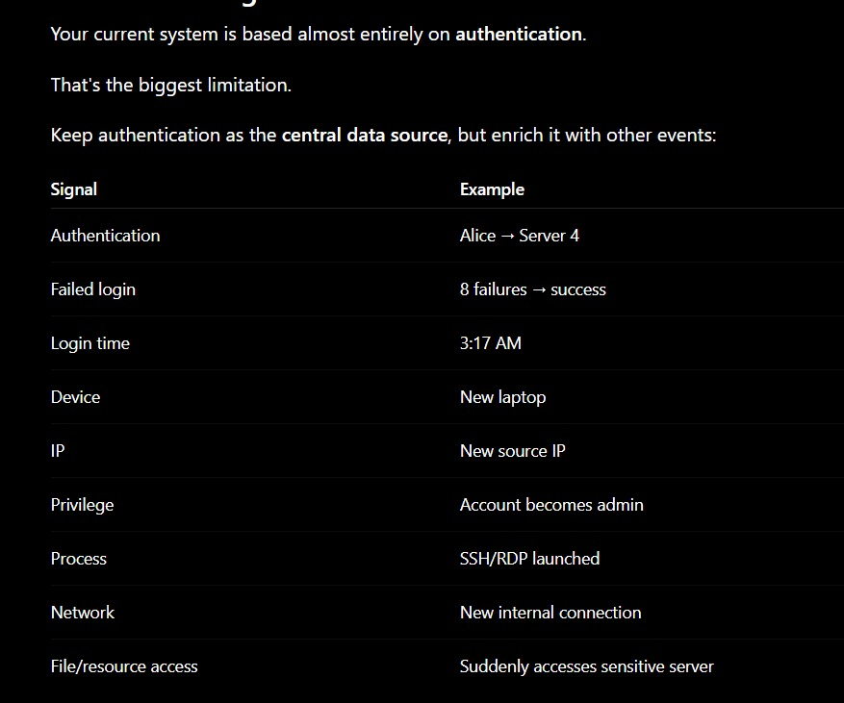
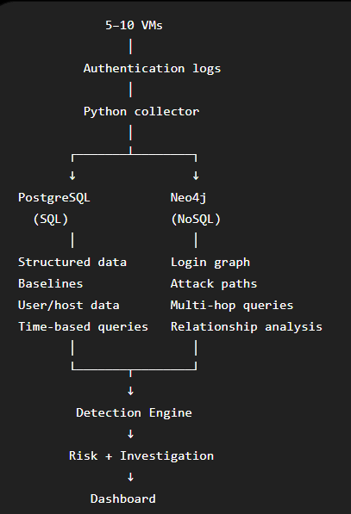
Project Features
- Real-time log collection – Collect authentication events continuously from 5–10 lab VMs using SSH/RDP and system login logs.
- SQL database management – Store users, accounts, hosts, roles, sessions, login events, baselines, and alerts in PostgreSQL.
- NoSQL graph database – Represent users, accounts, sessions, hosts, and their login relationships as a temporal graph in Neo4j.
- User behavioral baseline – Learn each user's normal hosts, login times, source machines, and typical access patterns from verified normal activity.
- Role-aware detection – Consider user roles and privileges so legitimate administrator activity is not automatically flagged.
- New-host detection – Identify logins to machines that are unusual or previously unseen for an account.
- Unusual-time detection – Detect authentication occurring outside an account's normal activity periods.
- Failed-to-success correlation – Identify suspicious patterns such as repeated failed logins followed by a successful login.
- Rapid login detection – Detect multiple machine accesses by the same account within a short time window.
- Multi-hop lateral movement detection – Identify chains such as Host A → Host B → Host C → Host D that may indicate lateral movement.
- Multi-account correlation – Detect suspicious activity involving multiple accounts connected through the same hosts, sessions, or source machines.
- Sensitive-host awareness – Assign higher risk to unusual access involving critical servers, databases, or domain controllers.
- Expected vs observed path analysis – Compare an account's normal access paths against the path observed during a suspicious event.
- Risk scoring – Combine multiple signals into an explainable risk score instead of using a simple hacker/not-hacker decision.
- Explainable alerts – Show exactly which factors contributed to an alert, such as new host, unusual time, rapid movement, or sensitive destination.
- Temporal attack graph – Display the sequence of machines and accounts involved in a suspicious event along with timestamps.
- Live attack-path visualization – Update the graph as new authentication events arrive during the demonstration.
- Near-real-time detection – Continuously process incoming logs and generate alerts within a few seconds.
- Analyst investigation dashboard – Provide a timeline, risk score, reasons, affected accounts, hosts, and attack path for each alert.
- SQL vs NoSQL comparison – Compare relational SQL queries with graph traversal for detecting multi-hop login paths.
- Query optimization – Use indexes, partitioning, materialized views, and EXPLAIN ANALYZE to improve SQL performance.
- Scalability testing – Benchmark detection queries on datasets ranging from thousands to millions of authentication events.
- Precision and recall evaluation – Measure detection effectiveness using known normal and simulated attack activity as ground truth.
- Public + custom dataset evaluation – Use LANL authentication data for large-scale benchmarking and your own VM-generated logs for controlled attack testing.
ER
1. What does a 1:N relationship mean?
- 1:1 — one entity on either side can be related to at most one entity on the other side.
- 1:N — one entity on the 1-side can be related to many entities on the N-side.
- M:N — many entities on either side can be related to many on the other side.
The most important trick is to read the relationship in both directions.
For example, look at ALERT — CONSISTS_OF — ALERT_PATH_HOP in your original diagram.
• One alert can contain multiple path hops.
• Each path hop belongs to one alert.

A. USER — HAS_BASELINE_ON — USER_HOST_BASELINE
The original diagram shows 1 beside USER and N beside USER_HOST_BASELINE.
- One user can have baseline records for multiple hosts.
- Each baseline record belongs to one user.

- Total participation — double line
- Every entity instance must participate in that relationship at least once.
- Example: if every stored path hop must belong to an alert, ALERT_PATH_HOP has total participation in CONSISTS_OF.

